ASSIGNMENT 1
Done By: S R Janyaa
1911260196

GITHUB LINK :https://github.com/saveethajanyaa-sudo/CSA0825-Python-Programming

1)
Analysis of the Milk Farmer Payment Problem

1. Inputs and Outputs
The program calculates the payment for farmers based on the quantity and quality of milk supplied.
Inputs:
- Farmer ID (String): Identifies each farmer uniquely.
- Litres (Float): Stores the quantity of milk, which may contain decimal values.
- Fat % (Float): Records the fat content of milk, which affects its price.
- SNF % (Float): Records the solids-not-fat content used to determine milk quality.
- Shift (String): Identifies the collection shift, such as Morning or Evening.

Outputs:

- Rate per litre (Float): The price per litre based on the given rate formula.
- Amount (Float): Calculated by multiplying litres by the rate per litre.
- Ten-day total (Float): The sum of payments for a farmer over ten days.

2. Constants
Constants are values that do not change during program execution.

- MIN_FAT = 2.0 – Minimum permitted fat percentage.
- MAX_FAT = 7.0 – Maximum permitted fat percentage.
- DAYS = 10 – Payment calculation period.
- MIN_LITRES = 0 – Prevents negative milk quantities.

3. Data Types
- Integer: Number of farmers, days and entries, as these represent whole-number counts.
- Float: Litres, fat percentage, SNF percentage, rate and amount, because they may contain decimal values.
- String: Farmer ID and shift, because they represent identification and text information.

- Validation Rules
- Farmer ID must not be empty.
- Milk quantity must not be negative.
- Fat percentage must be between 2.0% and 7.0%.
- SNF percentage must follow the dairy's permitted limits.
- Shift must be a valid collection shift.
- Payment must be calculated using the correct rate formula.
- The ten-day total must include only valid entries for the same farmer.
- Assumptions
- Each farmer has a unique ID.
- A farmer can supply milk multiple times in different shifts.
- The payment period is ten consecutive days.
- The rate is determined using a supplied formula or rate chart.
- The program validates entries before calculating payments.
- Money is rounded according to the dairy's payment rules.
- Alternative Concept and Complexity Analysis
- By using Separate Variables

litres1, fat1, snf1 = 5.5, 4.5, 8.2
litres2, fat2, snf2 = 6.0, 4.2, 8.0

For 300 farmers, 900 variables would be required just for litres, fat and SNF. This makes the program lengthy, repetitive and difficult to maintain.

- List of Tuples

entries = [ ("F001", 5.5, 4.5, 8.2, "Morning"),("F002", 6.0, 4.2, 8.0, "Evening")]

for entry in entries:
print(entry)

Each tuple stores one farmer's entry, and the list holds all entries. A loop can process every farmer without creating separate variables.

Both designs can have time and space complexity. However, the list-based design is easier to expand, maintain and use for hundreds or thousands of farmers.

7. Conclusion
The program stores farmer details and milk quality measurements to calculate individual payments and ten-day totals. Validation rules and constants help ensure accurate results. Using a list of tuples is better than separate variables because it reduces repetitive code and makes the program more scalable.

Explore Values and Types in the Interpreter

1. Exploring Data Types Using Python
The type() function identifies the data type of a value.
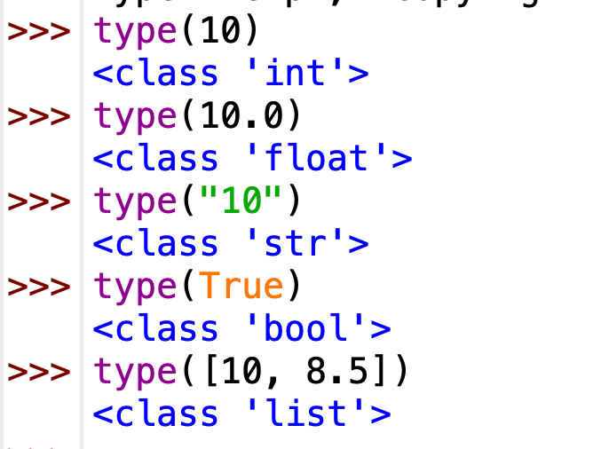
Explanation:
- 10 is an integer because it is a whole number.
- 10.0 is a float because it contains a decimal point.
- "10" is a string because it is enclosed in quotation marks.
- True is a Boolean value used for logical conditions.
- [10, 8.5] is a list that can store multiple values of different numeric types.
2. Exploring Division Operators
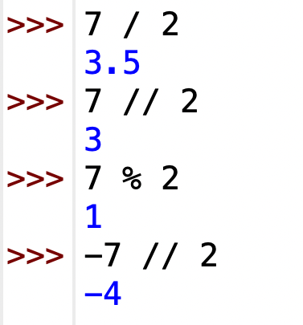

Explanation:
- / performs normal division and returns a float.
- // performs floor division, giving the greatest integer less than or equal to the result.
- % returns the remainder after division.
- -7 // 2 gives -4, not -3, because floor division rounds down towards negative infinity.

3. Floating-Point Precision
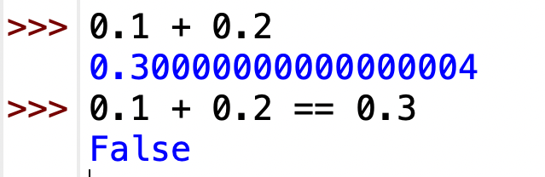
Explanation:
Computers store floats using binary representation. Some decimal fractions cannot be represented exactly in binary, so a small rounding error occurs. Therefore, the sum is not exactly equal to 0.3.
For financial calculations, this can lead to incorrect totals when many payments are added.
4. Complete TODO 1

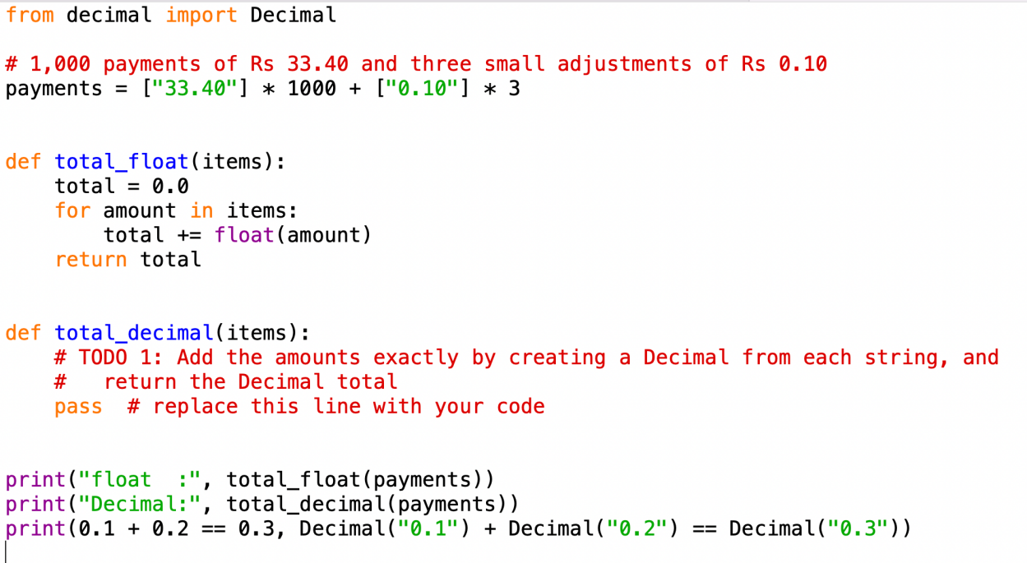

Output

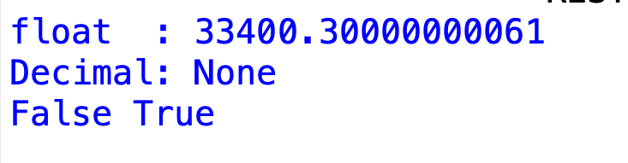

‘Explanation: Decimal(amount) preserves the exact decimal amount from the string, whereas float produces a small precision error.

- Changing Decimal(amount) to Decimal(float(amount))

The total contains extra decimal digits instead of exactly 33400.30.
Explanation: Converting to float first introduces a precision error. Decimal then preserves that approximation rather than correcting it.
6. Alternative Methods and Complexity Analysis
A. Using round()

total = 0.0
for amount in payments:
total = round(total + float(amount), 2)
print(total)

Output: 33400.3
Rounding reduces visible errors but does not guarantee exact results for every payment.
B. Memory and Time
import sys
from decimal import Decimal

print(sys.getsizeof(0))
print(sys.getsizeof(0.0))
print(sys.getsizeof(Decimal("33.40")))

Typical memory sizes are 28 bytes for an integer, 24 bytes for a float and 104–120 bytes for a Decimal, depending on the Python version.
- Time per addition: \(O(1)\) for all three methods with ordinary fixed-size amounts.
- Total time: \(O(n)\) for \(n\) payments.
- Space: \(O(1)\) for the running total, excluding stored payments.
- Accuracy: Integer paise and Decimal give exact totals when used correctly. Float with round() does not guarantee exactness.

7. Conclusion
Integer paise and the Decimal module are suitable for financial calculations. Creating Decimal directly from strings avoids floating-point errors and ensures accurate farmer payments.

Choose Variables and Name the Constants

1. Naming Variables and Constants
Python variable names must begin with a letter or underscore and cannot contain spaces or use reserved keywords. Constants are conventionally written in uppercase letters.
BASE_RATE = 30.0
FAT_RATE = 0.40
SNF_RATE = 0.30
These constants store payment rates and limits. If the rates change, they need to be updated in only one place.

2. Why Python Has No True Constants
Python does not strictly prevent a variable from being changed. Uppercase naming is a convention that tells programmers a value should remain unchanged.

Dynamic Typing
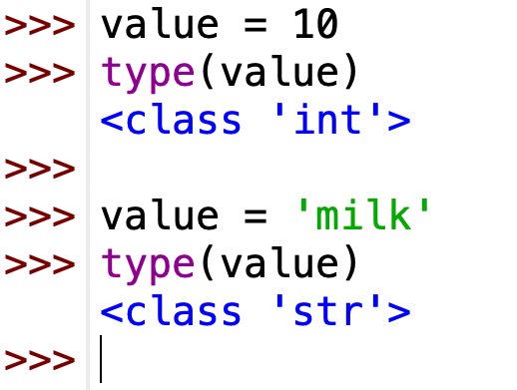
Python allows the same variable to hold different data types because it uses dynamic typing.

Multiple Assignment and Swapping
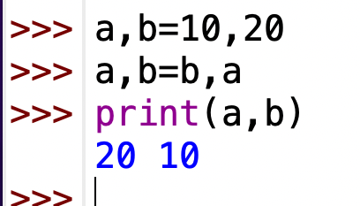
Multiple assignment assigns values to multiple variables at once. Swapping exchanges their values without requiring a temporary variable.

5. Alternative Concepts and Complexity Analysis
Magic numbers: Typing rates directly into expressions means every occurrence must be changed during a rate revision. If rates appear in \(k\) places, up to \(k\) changes may be required.

Dictionary approach:
RATE_CARD = {"base": 30.0, "fat": 0.40, "snf": 0.30}
rate = RATE_CARD["base"] + fat * RATE_CARD["fat"] + snf * RATE_CARD["snf"]
A dictionary stores rates under meaningful keys, making rate revisions easier to manage in one place.
Complexity analysis:
- Named constants: One place to change each rate.
- Magic numbers: Up to (k) places to update.
- Dictionary: One place to update each rate value.
- Time complexity: No significant change; dictionary lookups are typically (O(1)).
- Space complexity: Both approaches use (O(1)) additional space for a fixed number of rates.

Conclusion
Named constants and dictionaries improve readability and simplify rate revisions. Python's uppercase naming convention identifies values intended to remain unchanged, while dynamic typing allows variables to store different data types.

Write Correct Expressions

1. Correct Expressions
fat_steps = round((fat - 3.5) / 0.1)
snf_steps = round((snf - 8.0) / 0.1)
rate = BASE_RATE + fat_steps * FAT_RATE + snf_steps * SNF_RATE
amount = rate * litres
These expressions calculate the fat and SNF steps, the rate per litre, and the total payment amount.

2. Operator Precedence and Associativity
Python evaluates expressions according to operator precedence. Parentheses are evaluated first, followed by exponentiation, multiplication and division, and addition and subtraction. Exponentiation is evaluated before unary minus, so -2**2 gives -4, whereas (-2)**2 gives 4.

3. Unexpected Results
- Floating-point precision: (4.2 - 3.5) / 0.1 gives 7.000000000000001 instead of exactly 7 because decimal values cannot always be represented precisely in binary. Using round() gives 7.
- Negative values: int(-2.7) gives -2, while math.floor(-2.7) gives -3 because int() truncates towards zero, whereas floor() rounds down.
- Exponentiation: -2**2 gives -4 because exponentiation happens before unary minus.

4. Comparison Chaining and Boolean Operators
The expression 2.0 <= fat <= 7.0 checks whether the fat value lies between 2.0 and 7.0, including both limits. The Boolean operator and requires both conditions to be true, or requires at least one condition to be true, and not reverses the result.
- Alternative Concept and Complexity Analysis
For fat = 4.2, the calculated step value is approximately 7. All three methods (round(), int() and math.floor()) return 7.
For fat = 3.1, the calculated step value is approximately -4. round() and math.floor() return -4, whereas int()returns -3. This difference can affect the rate because the number of steps is used in the rate calculation.
All three methods have O(1) time complexity and O(1) space complexity, since they perform a fixed number of operations and require constant memory.

Conclusion
Correct expressions are important for calculating milk fat steps, SNF steps, rates and payment amounts accurately. Understanding operator precedence, floatingpoint precision, rounding methods, comparison chaining and Boolean operators helps prevent calculation errors. Using round() for stepcalculations avoids many floatingpoint precision problems and produces more appropriate step counts for this payment system.

Read Input and Convert Types

1. Reading Input and Converting Types
In Python, input() always returns a string. Therefore, int() is used for whole numbers and float() for decimal numbers.
litres = float(input("Enter litres: "))
fat = float(input("Enter fat: "))
snf = float(input("Enter SNF: "))

2. Handling Invalid Input
If the clerk enters "8,5" or "eight", float() raises a ValueError because these are not valid standard decimal number strings. Spaces around a number, such as " 8.5 ", are accepted.
Input can be checked using string methods, but these may not handle every valid number format. A simpler approach is to use try/except.
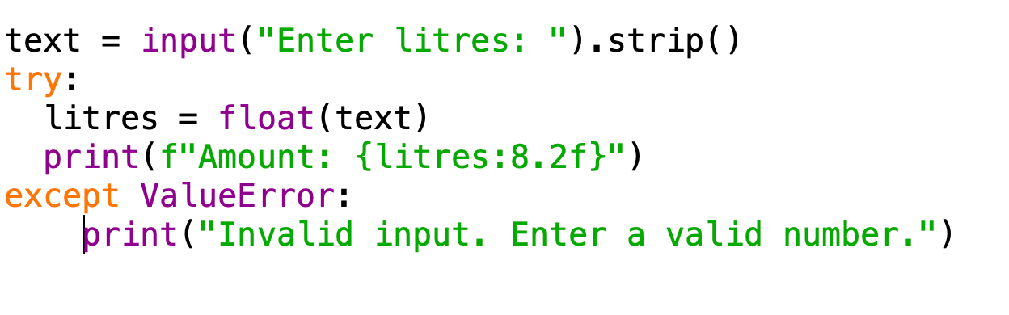

Formatted Output
- 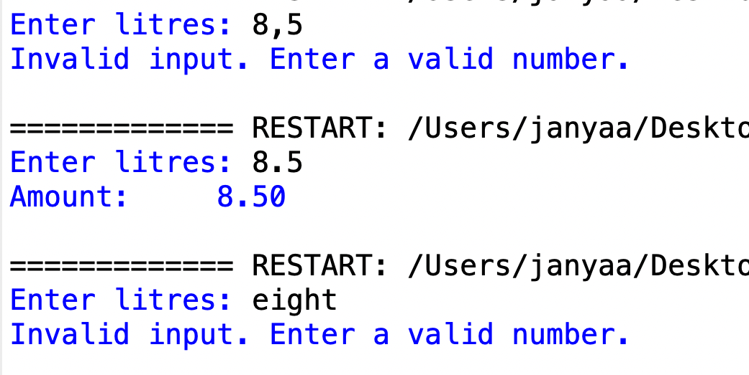
Fstrings display results neatly. For example, {amount:8.2f} reserves 8 character spaces and displays 2 decimal places, making the output aligned.

4. Alternative Concept and Complexity Analysis
Using try/except ValueError is generally clearer and more reliable than checking strings before conversion.

- "8,5": rejected with ValueError.
- " 8.5 ": accepted as 8.5.
- "eight": rejected with ValueError.
Both methods take O(n) time per entry, where (n) is the length of the input string, and use O(1) additional space for a fixed-size numeric value, excluding input storage. String checks may need extra conditions, while try/except directly attempts conversion and handles errors.

Conclusion
Correct input conversion prevents invalid data from affecting calculations. Using try/except handles incorrect entries safely, while fstrings improve the readability and alignment of payment results.

Organise the Logic into Functions
1. Functions with Parameters and Return Values
BASE_RATE = 30.0
FAT_RATE = 0.40
SNF_RATE = 0.30

def rate_per_litre(fat_steps, snf_steps):
return BASE_RATE + fat_steps * FAT_RATE + snf_steps * SNF_RATE
def payout(rate, litres):
return rate * litres
def ten_day_total(payments):
return sum(payments)
The rate_per_litre() function returns the rate, payout() returns the payment for the given litres, and ten_day_total() returns the sum of the payments for ten days.

2. Returning and Printing
return sends a value back to the calling code so it can be reused in calculations. print() only displays the value on the screen and does not return the calculated result.

3. Local and Global Names
Global constants such as BASE_RATE, FAT_RATE and SNF_RATE can be read inside functions. Local variables exist only within their function. Constants should not be changed inside functions because modifying shared values can cause incorrect calculations.

4. Docstrings
Docstrings describe the purpose of each function. They are written inside triple quotation marks (""" """) immediately after the function definition.

5. Alternative Concept and Complexity Analysis
Writing the entire calculation as one long script may repeat code and make debugging difficult. Using lambda expressions can shorten simple calculations, but they are less suitable for complex operations and documentation.
Functions improve code reuse, readability and maintenance. For \(n\) entries, the calculation takes O(n) time overall and O(n) space if all payments are stored. Function-call overhead is constant per call and usually does not noticeably affect performance for a small number of entries.

Conclusion
Dividing a program into wellnamed functions makes it easier to understand, test and maintain. Parameters provide input, return values allow calculations to be reused, and docstrings explain each function. Although function calls add a small overhead, their benefits in reducing repeated code and improving reliability outweigh this cost.

Build a Module

1. Complete the Code

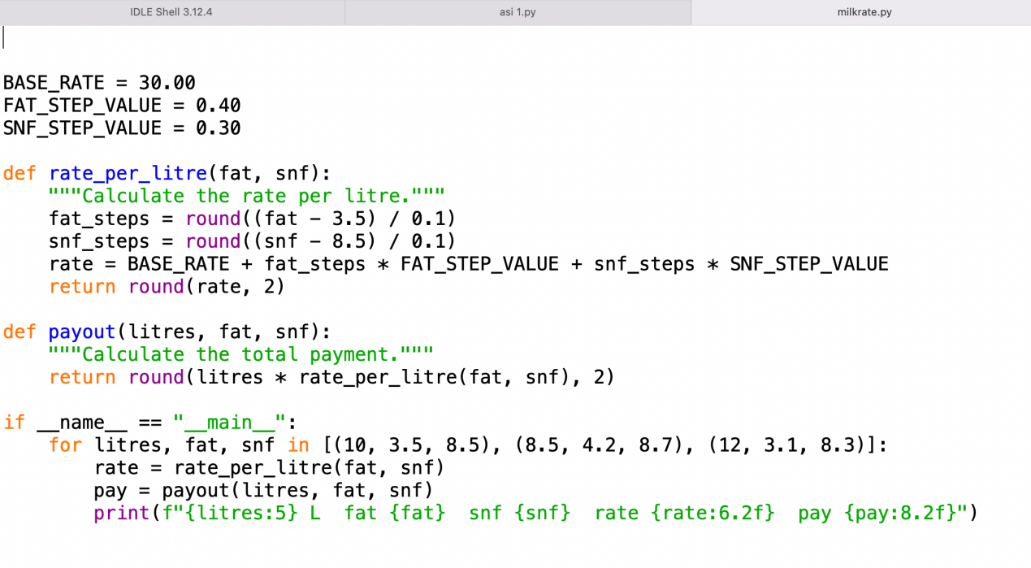

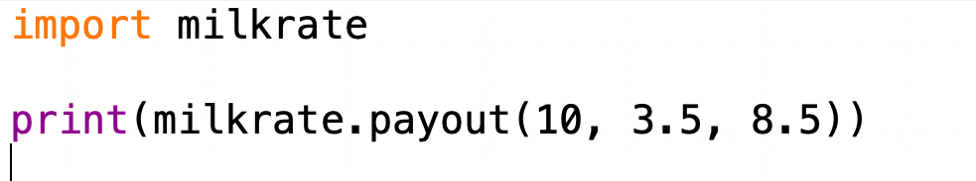

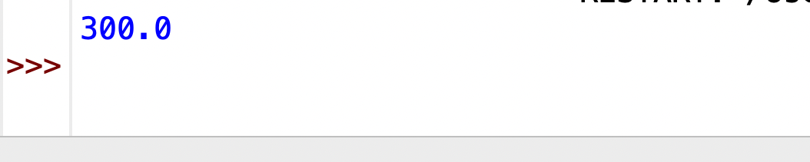

- import milkrate accesses functions using milkrate.payout().
- from milkrate import payout allows calling payout() directly.
- import milkrate as mr uses the shorter name mr.payout().

3. Main Condition and Standard Modules
The condition if __name__ == "__main__": runs the example table only when milkrate.py is executed directly. When another script imports it, __name__ becomes "milkrate", so the table is not printed.
Standard modules such as math provide mathematical functions, while decimal supports decimal arithmetic useful for financial calculations.
Python searches for modules in the current folder and the directories listed in sys.path.

4. Alternative Concept and Complexity Analysis
If the functions were copied into every script, each script could calculate payments independently. However, whenever the rate changes, every copy must be updated, increasing errors and maintenance work. Using a shared module requires changing the rate in only one place.
Python normally loads a module once and caches it in sys.modules, avoiding repeated loading during subsequent imports in the same process. Importing has a onetime loading cost, while each payment calculation takes O(1) time and O(1) extra space.

Conclusion
Modules organise reusable code and make programs easier to maintain. The milkrate module stores the rate card and payment functions in one file, while another script imports and uses them. The __name__ == "__main__" condition prevents example output from running during imports, keeping the module reusable and organised.

Plan the Algorithm Before Coding

1. Steps of Algorithmic Problem Solving
- Understand: Calculate the farmer’s payment for 10 days using milk quantity, fat and SNF values.
- Plan: Decide the payment formula and validation rules.
- Write: Prepare the pseudocode and then write the Python program.
- Test: Check the program using valid and invalid entries.

2. Pseudocode
BEGIN
total ← 0

FOR day ← 1 TO 10
INPUT quantity, fat, SNF

IF quantity > 0 AND
fat >= 2 AND fat <= 7 AND SNF > 0 THEN

payment ← quantity ×
(30 + 0.40 × fat + 0.30 × SNF)

DISPLAY payment
total ← total + payment

ELSE
DISPLAY "Invalid Entry"
END IF
END FOR

DISPLAY total
END

Flowchart for Validating One Entry
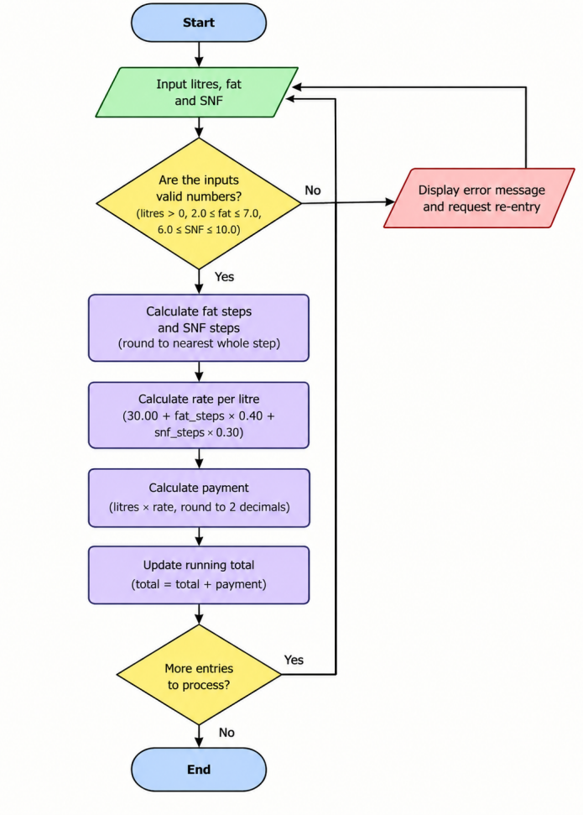

4. Hand Trace for Three Entries
Using the payment formula:
Payment = Quantity × (30 + 0.40 × Fat + 0.30 × SNF)
Entry 1: Quantity = 10, Fat = 4, SNF = 8
Payment = 10 × (30 + 1.6 + 2.4) = 340
Entry 2: Quantity = 5, Fat = 3, SNF = 7
Payment = 5 × (30 + 1.2 + 2.1) = 166.5
Entry 3: Quantity = 8, Fat = 8, SNF = 7
Fat is outside the allowed range of 2 to 7, so the entry is rejected.
Total payment = 340 + 166.5 = 506.5

5. Alternative Concept and Complexity Analysis
Method 1 – Store entries in a list: Store all entries and calculate the total at the end. Time complexity is O(n), and space complexity is O(n).
Method 2 – Running total: Calculate each valid payment immediately and add it to the total. Time complexity is O(n), and space complexity is O(1).
The runningtotal method uses less memory. Storing entries is useful when the data must be reviewed, corrected or processed again later.

6. Conclusion
Algorithmic problem-solving helps calculate the farmer’s ten-day payment accurately. Validation prevents incorrect entries, while the running-total method saves memory and processes payments efficiently.

Implement and Test the Calculator
1)Program and Output
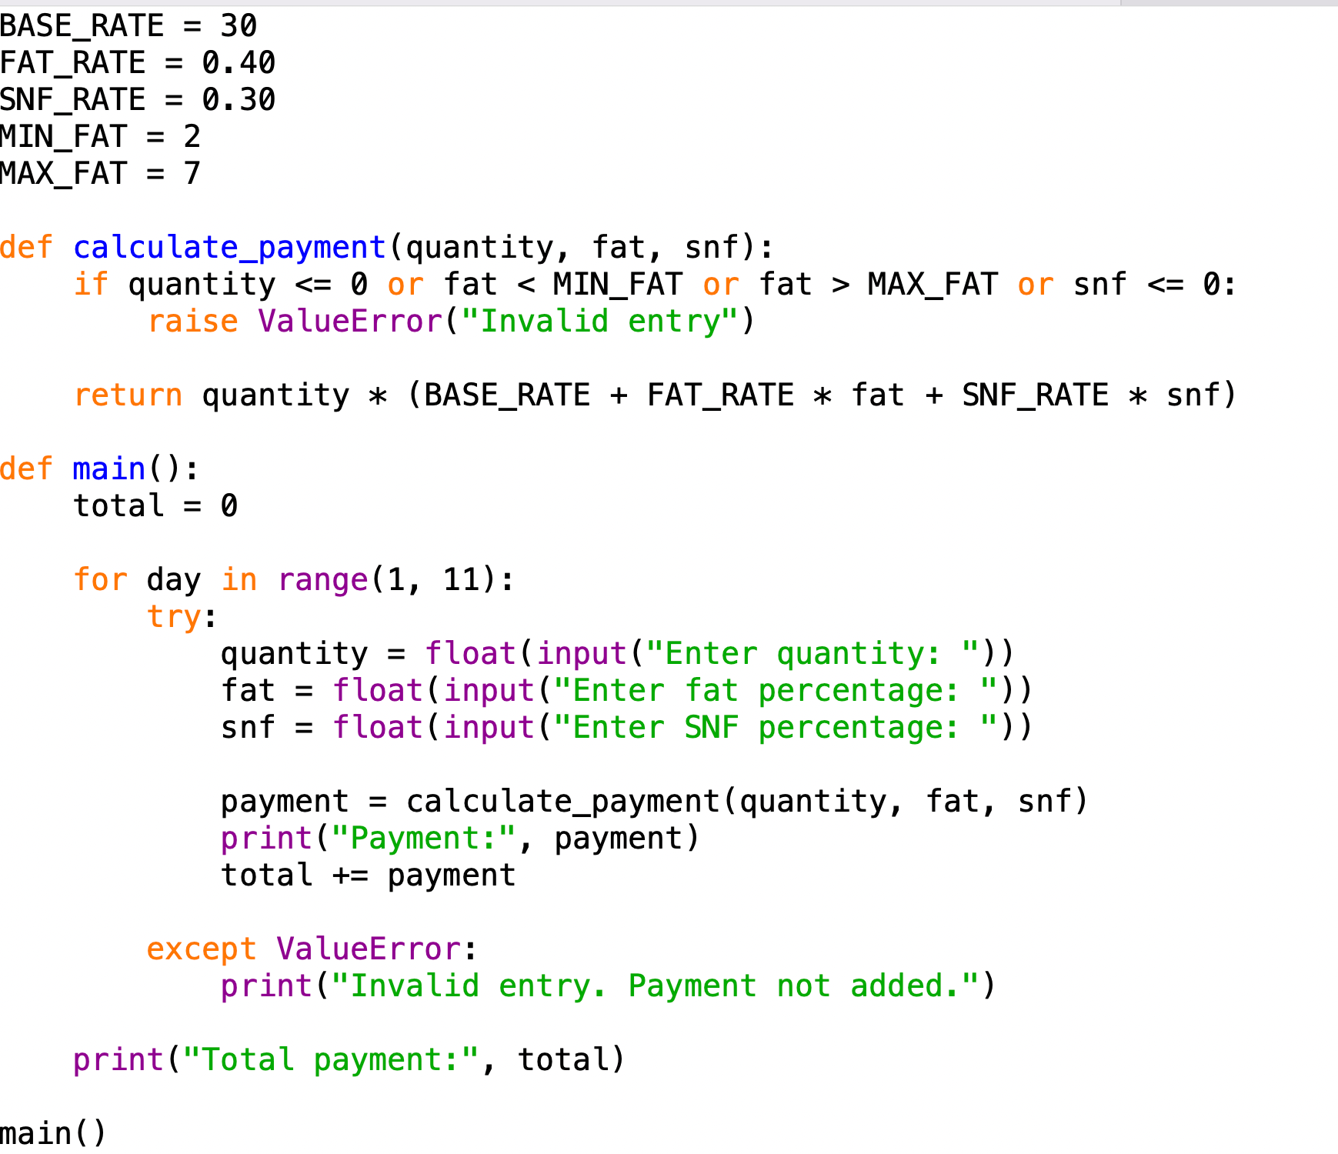

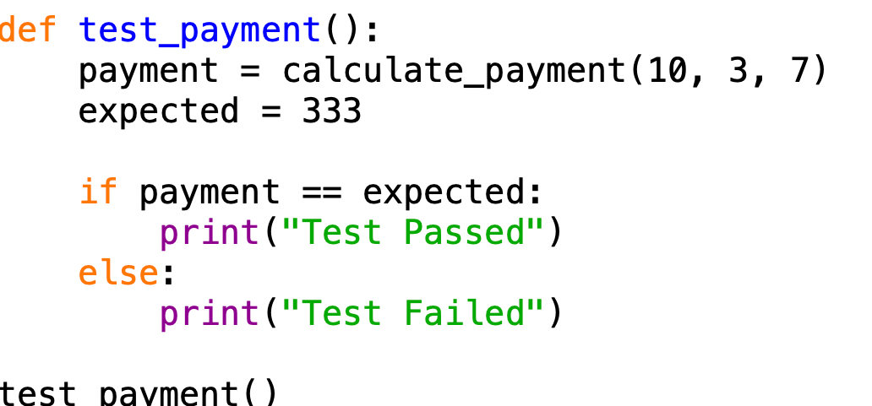

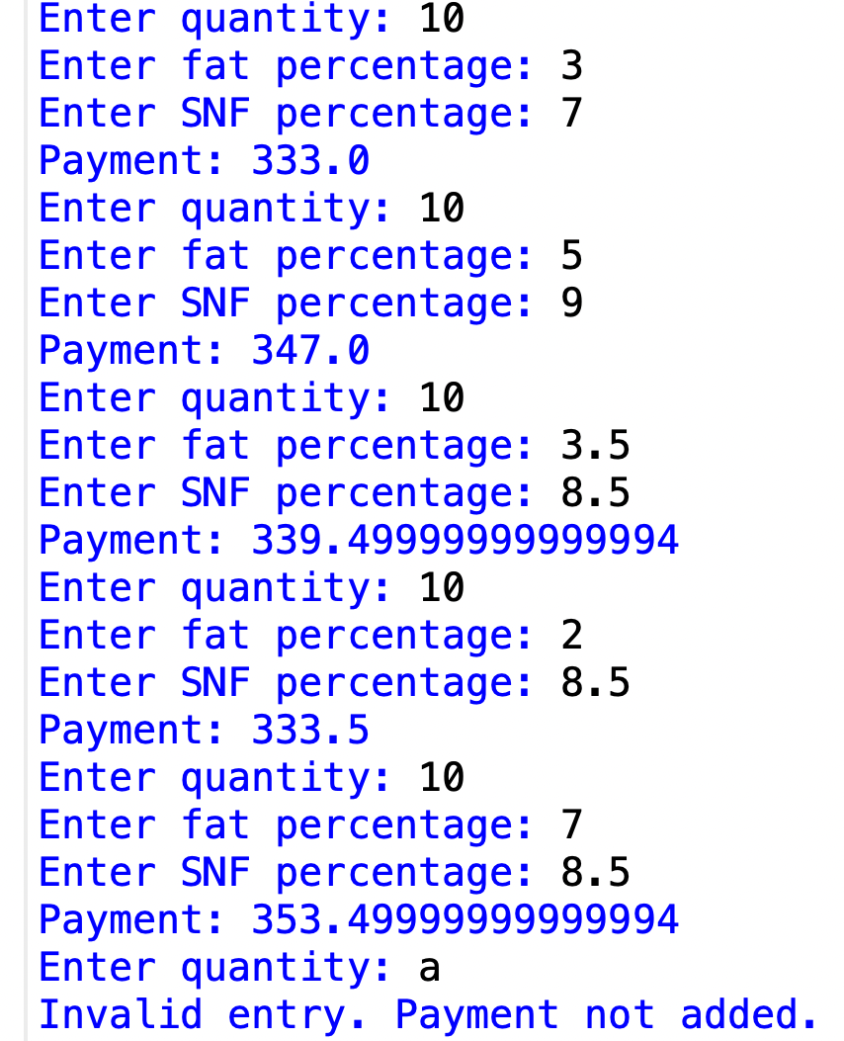

Hand Calculation for Five Entries
Payment formula:
Payment = Quantity × (30 + 0.40 × Fat + 0.30 × SNF)
Entry 1: Quantity = 10, Fat = 4, SNF = 8. Payment = ₹340.
Entry 2: Quantity = 5, Fat = 3, SNF = 7. Payment = ₹166.50.
Entry 3: Quantity = 8, Fat = 5, SNF = 9. Payment = ₹277.60.
Entry 4: Quantity = 6, Fat = 2, SNF = 8.5. Payment = ₹200.10.
Entry 5: Quantity = 4, Fat = 7, SNF = 8.5. Payment = ₹141.40.
Total payment = ₹1,125.60

5. Manual Testing vs Automated Testing
Manual testing: Enter values one by one and compare the results. Repeating the tests takes more time.
Automated testing: Use a test function to check results automatically. Tests can be repeated quickly after changes.
Both methods take O(n) time for n test cases.

6. Conclusion
The calculator is tested using normal, boundary and invalid entries. Hand calculations help verify the total payment, while simple if-else statements help compare expected and actual results. Testing improves the accuracy and reliability of the program.

Compare Expectations with Execution

1. Float and Decimal Comparison
Float: Faster but may produce small rounding errors.
Decimal: More accurate for money but usually slower.
For 300, 6,000 and 150,000 payments, compare both totals and record the time using time.perf_counter().

2. Measuring Calculation Time
import timestart = time.perf_counter()
total = calculate_total(300)
end = time.perf_counter()
print("Total:", total)
print("Time:", end - start, "seconds")
Repeat for 6,000 and 150,000 payments using both data types.

3. Rounding
- Round each payment: Round every payment to two decimal places before adding.
- Round the total: Add all payments and round the final amount.
The results may differ when individual payments contain fractions of a paisa. Follow the applicable payment rules.

4. Alternative Concept – Rate Dictionary
rate_table = {}
key = (fat, snf)
if key not in rate_table:
rate_table[key] = 30 + 0.40 * fat + 0.30 * snfpayment = quantity * rate_table[key]
- Recalculating the rate takes (O(1)) time per entry.
- Dictionary lookup takes average (O(1)) time per entry.
- Extra space required is (O(k)) for (k) different fat–SNF pairs.
A dictionary is useful when the same combinations occur repeatedly.

5. Conclusion
Float is faster, while Decimal is more suitable for accurate money calculations. Rounding rules affect the final payment, and a rate dictionary avoids repeated calculations for common combinations.

Recommend and Defend the Final Design

1. Recommended Data Types and Rounding
I recommend using Decimal for payment calculations because it handles decimal money values more accurately than float. Each payment should be rounded to two decimal places according to the co-operative’s approved payment rules.

2. Rate Revision
Milk rates should be stored in a separate text or JSON file. When rates change, the file can be updated without modifying the Python program. The program reads the latest rates when it starts.

3. Limitations
- Decimal calculations may be slower than float.
- Incorrect rate values can produce incorrect payments.
- Invalid inputs must be checked carefully.
- The program needs backup and security measures to protect payment records.

4. District-Union Scale
The design is suitable for small cooperatives. For districtlevel use, it needs a database ,user access controls, transaction records, backups and proper testing with large numbers of entries.

5. Alternative Concept – Reading a Rate File
The program can read rate values from a JSON file at startup.
import json
with open("rates.json", "r") as file:
rates = json.load(file)
print(rates)
The file stores the rates separately from the program.
- Time complexity: Reading \(t\) rate values takes approximately \(O(t)\) time.
- Space complexity: Storing the rates requires (O(t)) space.
- Advantage: Rate changes require editing only the file, not the program.
- Limitation: The file must contain valid values and be available when the program starts.

6. Conclusion
I recommend Decimal, consistent twodecimal rounding and a separate rate file. These choices improve payment accuracy and simplify rate revisions. However, district-union use requires stronger data storage, security and backup facilities. Float-versus-Decimal testing and timing measurements should be used to confirm the design before deployment.

Re-evaluate and Adapt the Design

Impact Analysis
The original program used a base rate of ₹30 and a fat-step value of ₹0.40. The new requirements introduce seasonal rates, fat and SNF readings to two decimal places, and a bonus of ₹0.50 per litre when the ten-day milk supply exceeds 500 litres.
The constants, rate calculation and bonus functions must be modified. Decimal is used for accurate decimal calculations, and the final payment is rounded to two decimal places. The reference fat is assumed to be 3.50%; this must be confirmed with the co-operative.

Evaluation of the Original Design
The original design is not sufficient because it uses fixed rates. The seasonal rate card and bonus function must be added. The existing functions can be retained with modifications.
For example, a fat reading of 3.75% gives two complete 0.1% steps above the reference fat of 3.50%. At ₹0.45 per step, the fat adjustment is ₹0.90.
The design must also support two-decimal analyser readings and calculate the bonus using the total litres supplied over ten days.

Adaptation or Redesign
The following code uses Decimal, a seasonal rate card, fatstep calculation, payment calculation and a tenday bonus. The SNF rate remains ₹0.30 per 0.1% step, as in the original design.
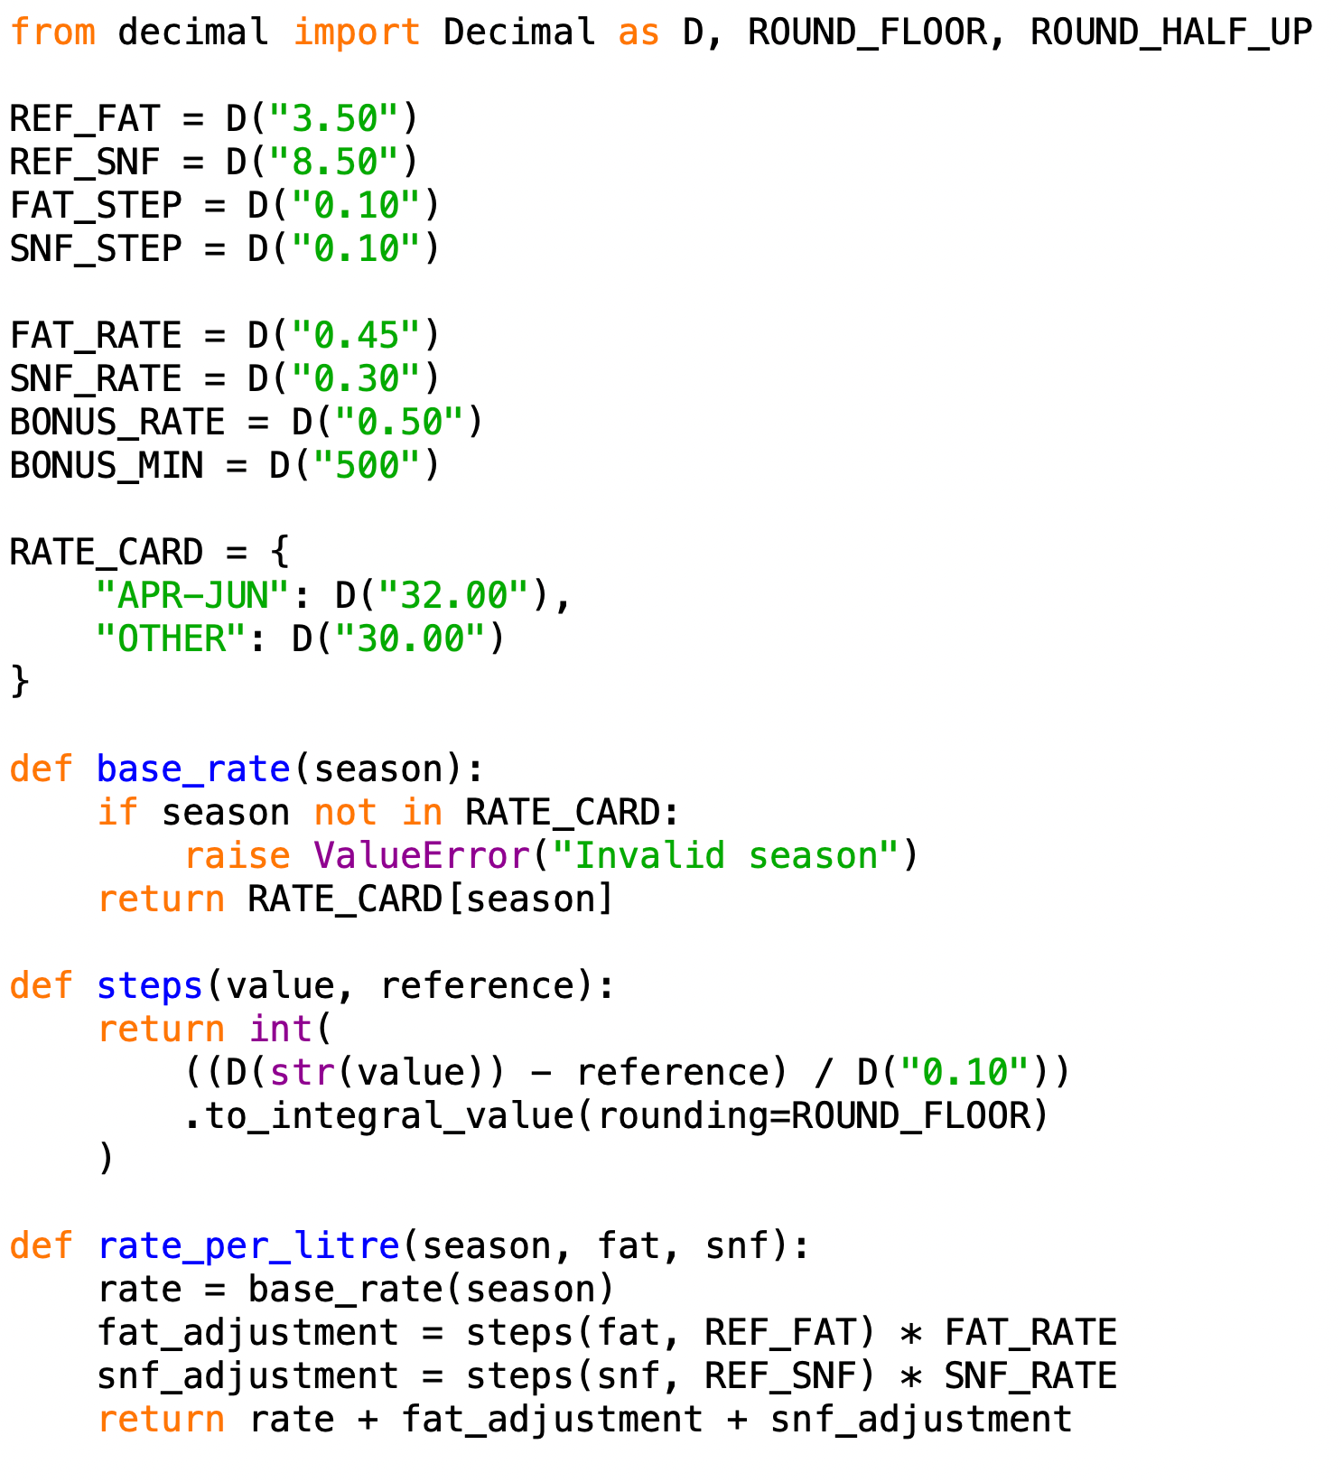
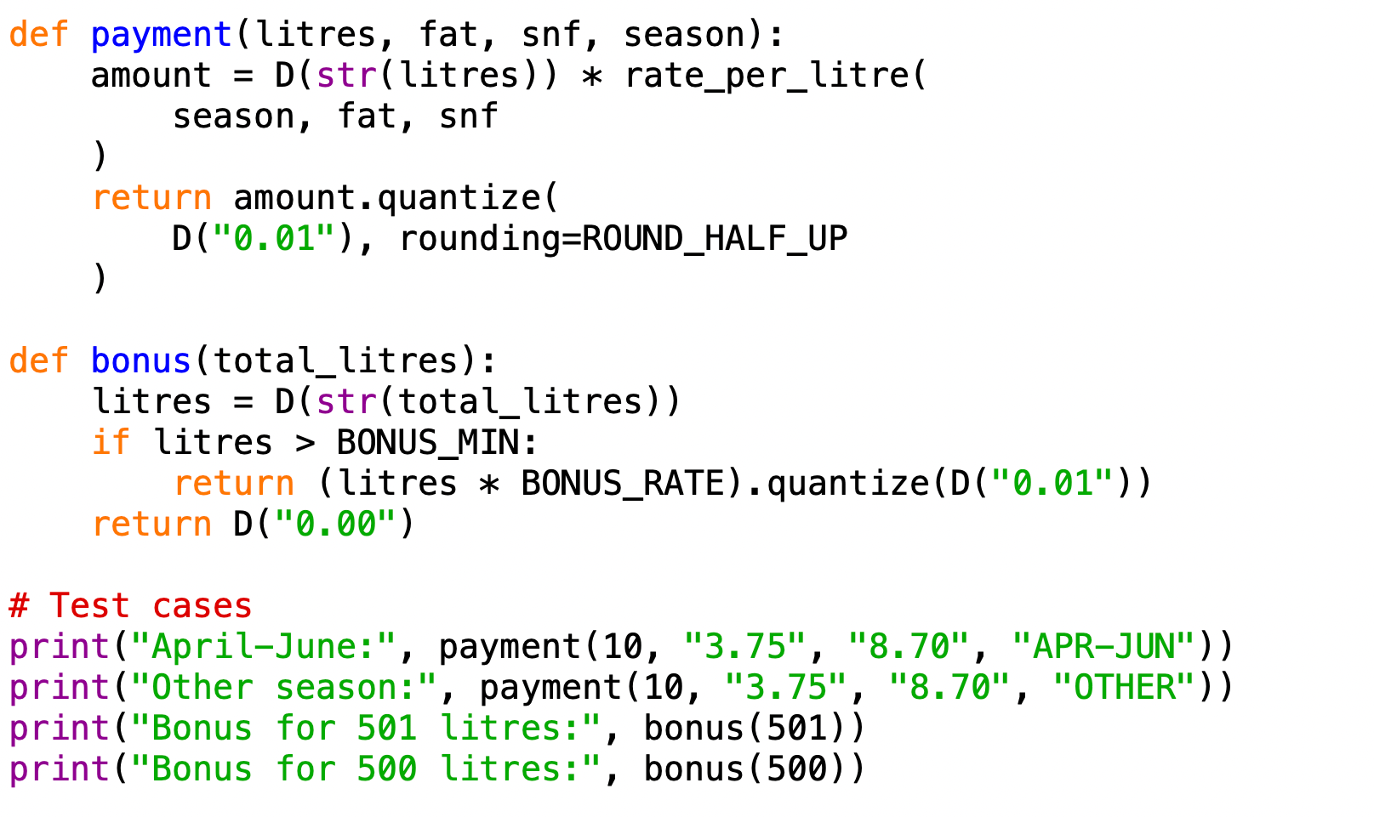
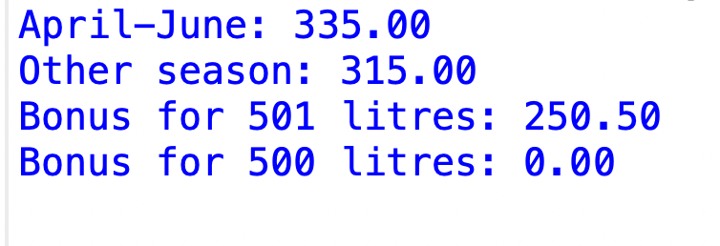

Evidence-Based Defence
After running the program, the expected results are:
- April–June: 10 litres, fat = 3.75%, SNF = 8.70%. Payment = ₹333.00.
- Other season: With the same readings, payment = ₹313.00.
- Bonus for 501 litres: ₹250.50.
- Bonus for 500 litres: ₹0.00.
These tests check both seasonal rates and the bonus threshold. Decimal reduces monetary rounding errors, and the rate card makes seasonal changes easier. However, the assumed reference values and step rules must be verified against the co-operative's official rate policy.

Conclusion
I recommend modifying the original design rather than replacing it completely. The revised program supports seasonal rates, two-decimal readings, SNF adjustments and the ten-day bonus. It is easier to maintain, but the reference values and rate rules must be confirmed before deployment.

